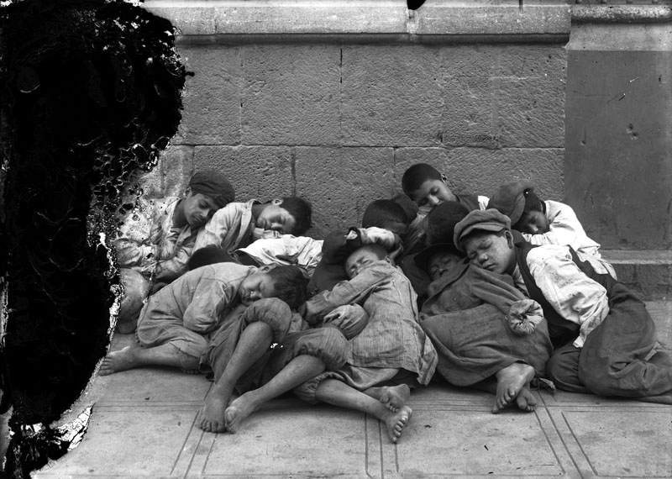

Newsboys sleep in the street, Mexico City, 1923. Child Labor – Survival

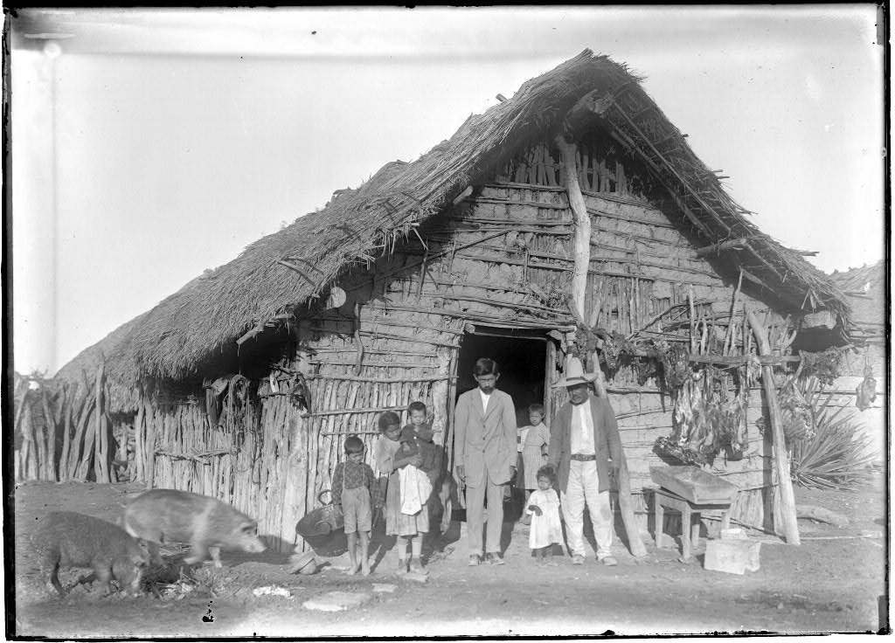

Picture of working family in Mexico, 1913

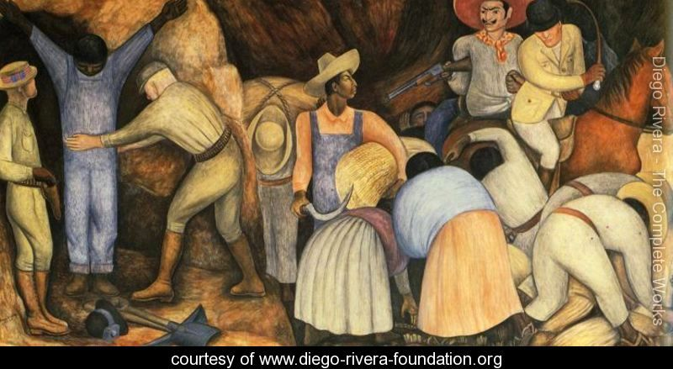
Diego Rivera, The Exploiters (Los explotadores, 1926)—depicts unequal relationship between Mexican field workers and wealthy landowners: http://ww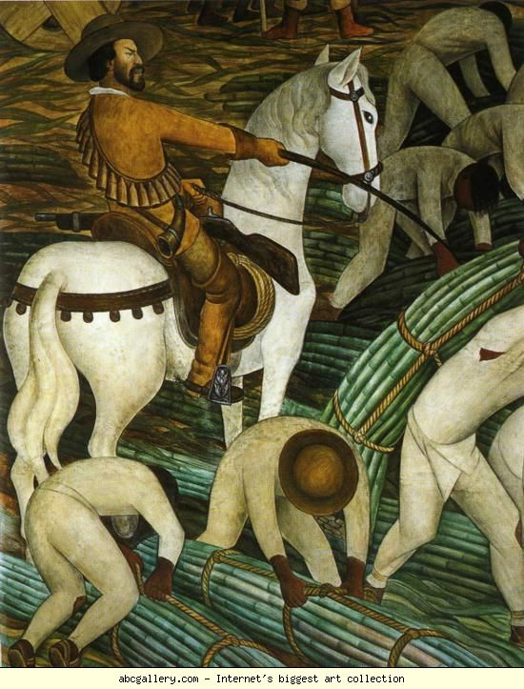w.diego-rivera-foundation.org/The-Exploiters-1926-large.html
Diego Rivera, Sugar Plantation (Plantacíon de cañas de azúcar, 1931)—mural depicting land owner and workers (1920s Mexico): http://www.abcgallery.com/R/rivera/rivera139.html

