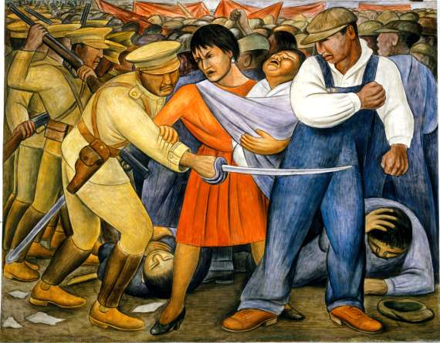
The Uprising (El Kevantiamento), 1931
A woman holding a baby and a working man fend off an attack by a uniformed soldier. Behind them a crowd clashes with more soldiers who force demonstrators to the ground - a potent symbol for universal class struggles.

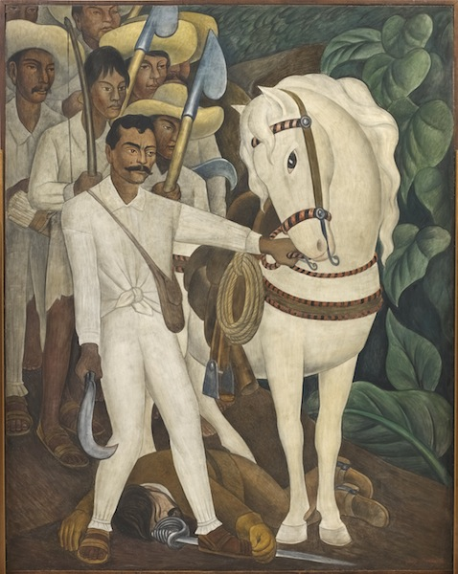
Agrarian Leader Zapata (Lider Agrario), 1931
Emiliano Zapata, champion of agrarian reform and a key protagonist in the Mexican revolution leads a band of peasant rebels who are armed with makeshift weapons, including farming tools. He stands above the body of a hacienda owner. An image of violent but just revenge.
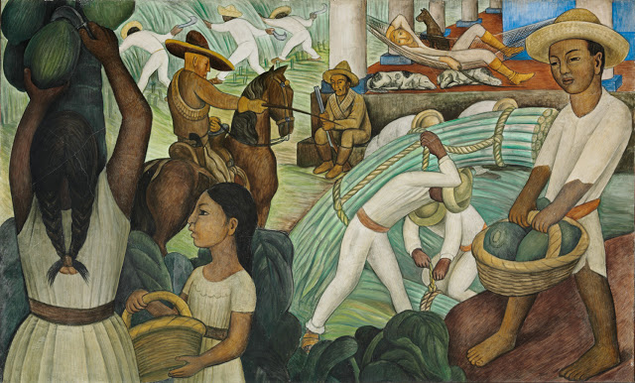
Sugar Cane, 1931
In the foreground a woman cuts papayas from a tree while her children collect the fruit in baskets. A foreman, with lighter skin and hair watches over them on horseback while in the background an even lighter hacendado (plantation owner) lounges on a hammock.
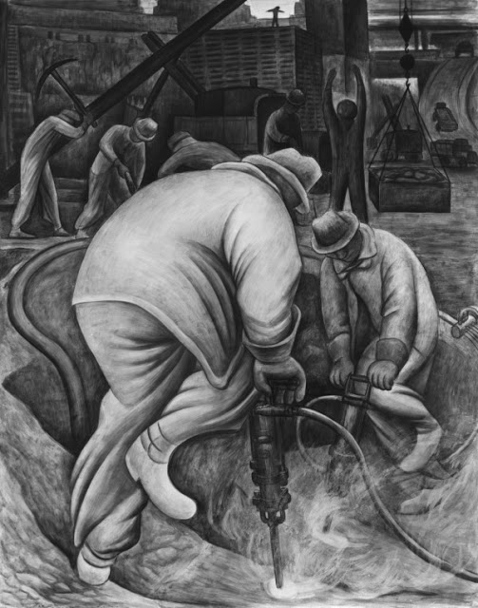Pneumatic Drilling, 1931
The figures in this mural use a pneumatic drill and a jackhammer to bore into New York's foundation. When Rivera arrived in New York the city was in the throes of the greatest construction drives of all time, made possible by the armies of surplus labour that were available during the Depression.
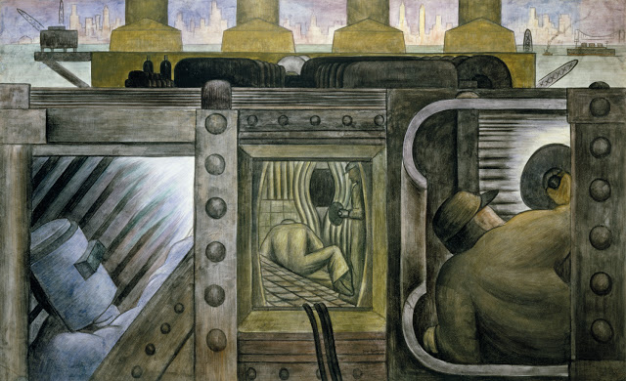
Electric Power, (Energia Electrica), 1931-32
Situated just below New York city's jagged skyline, a steel and cement power plant interior - deep in the inner workings of the city are to be found the workers that power that city.
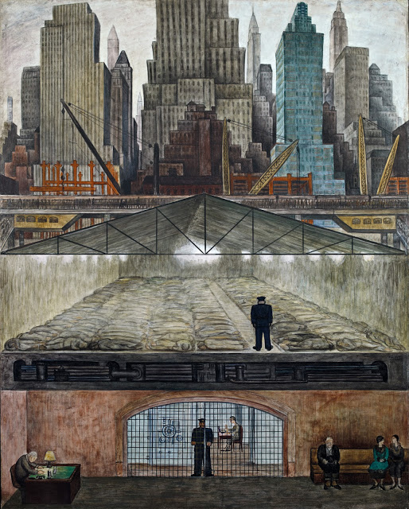
Frozen Assets (Fondos Congelados), 1931-32
In this mural Rivera launches into a critique of the inequality of New York society. The upper panel features a sequence of easily recognisable skyscrapers. Just below that, are the masses trudging to work. In the next section a steel and glass shed serves as shelter for rows of sleeping men (overseen by a hudrant shaped policeman), pointing to the dispossed labour that made possible the city's extraordinary growth at a time of economic upheaval. Below, in the bank's waiting room are a clerk, a guard and three figures eager to inspect their mounting wealth in the vault inside which, another figure is doing exactly that.
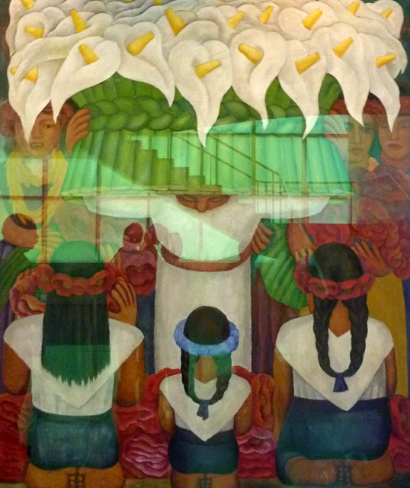
Flower Festival: Feast of Santa Anita (Festival de las Flores: Fiesta de Santa Anita), 1931, (encaustic on canvas)

